
ReadMe Template Worksheet

Your ReadMes are the key deliverable that engineers will want to see as part of your job search. Each engineering team will look at different aspects of your ReadMe and repo. Some will go into the code itself and explore. Others will just want to see the showcase code snippets in the main ReadMe. Some will read the full thing to understand your approach, others will skim to specific sections.

It’s crucial that you cover all the different sections below to ensure that you’ve got the information for all engineers that check these out.

We regularly have employer partners discuss the importance of the ReadMes in what they’re looking for and why they interview the grads that they do - so don’t underestimate the importance of writing strong ReadMes!

For any pair or group project, you cannot share a ReadMe. These must be written independently to ensure that the engineers reading this understands your specific experience and approach.

It’s a good idea to start your ReadMes during the planning stage as this is the best way to get ahead and save time when it comes to finalising your first draft post-project. As you plan each aspect of your project, note down what you intend to do with screenshots of your plan and anything else you think would be useful, then when you execute this part in your code, you can adjust this part of your ReadMe as needed depending on how your process changed, or if it went as planned then you can leave it as it is.

Make a copy of this document for each project you use throughout the course and fill in each section. Keep your copy in your Outcomes folder, so the team is able to add feedback into your docs.

Once the content has been finalised by the Outcomes team, you can then upload these onto your GitHub repository later.

Things To Consider:

- That there are no spelling mistakes in your ReadMe - if you see a spelling error highlighted below, edit this.
  - Some engineers will reject applicants if their ReadMes are full of mistakes. From their perspective, if your ReadMes are full of mistakes, what is your code like…

- That your technologies are capitalised correctly - i.e JavaScript, jQuery, MongoDB

- That your formatting is consistent throughout - headers, indentation, full stops in bullets etc

- Any hyperlink included works

- That you include images throughout - code snippets, pictures of your planning stage, screenshots of the final project.
  - These can be still screenshots or gifs
  - This breaks up the text in your ReadMe and helps to keep the reader engaged

- That your ReadMe sounds like you - see this as an opportunity to showcase who you are to the engineering community and prospective employers.
  - Think back to the Personal Brand session and how employers want to get a sense of who you are. The content you write should sound as if you’re talking through your experience.

ReadMe Sections

Description

Instructions

Here, give a short description of the project. It can be a couple of sentences where you discuss the point in time during the course that you completed it, the topic of the project and potentially the tech stack.

Insert your Description here:
Frogger is an arcade game. You must pass all the car without be hit by the obstacles, and if you have luck enough, you will reach the final point, where the winners are, and you will score 100 points, for every time you can make it, till you lost your lives.

Deployment link

Instructions

Here include the information on where the deployed project can be found. If login details are needed to access the full project, make sure you include them.

If you have not yet deployed your project, you can add this in later.

Insert your Deployment link here:

https://gibacarnieli.github.io/Frogger/

Getting Started/Code Installation

Instructions

Explain how the reader accesses your code. Include a step by step approach.

Insert your Getting Started/Code Installation here:

Timeframe & Working Team (Solo/Pair/Group)

Instructions

Share the timeframe given for the project and whether you worked independently, in a pair, or in a group.

If you worked in a pair or group, include the names of the people you collaborated with. As a bonus, you can also provide links to their GitHub repo.

Insert your Timeframe & Working Team here:
I had one week to build this grid-game using JavaCript, HTML and CSS. I choose to do the normal version of frogger, instead of changing the characters of the game. I did it independently, and my version of this game don’t have levels, it has points for be reached.
For you navigate truth the game, you must use the keyboard arrow buttons while you cross the street.
Technologies Used

Instructions

List every technology you used to complete the project. This can be in one long list, or broken down into categories (Back End, Front End, Development Tools).

Insert your Technologies Used here:
HTML
- Grid with 100 cells, 10 rows and 10 columns.
- ‘Start’ button for game start and the audio start.
- Audio Element for background music.

CSS
- Grid using flex-box

JavaScript
- keyUp event to move the characters.
- Interval to move obstacle.
- Click events to start the game.

Brief
Instructions

Include the brief set by your instructional team here. This sets the context of the project you were working towards and mimics briefs you will be set later in your future roles.

This can either be in bullets or in a paragraph.

Insert your Brief here:

The brief from GA was to build a game, able to move around the grid and able to score points. Could it be 1 player or more. We had a list of alternatives and I choose the frogger.
Planning

Instructions

The planning stage is important, as all projects in your future roles will have detailed plans before any coding happens. It is a great experience to share with potential engineer employers, as this reflects real engineering team practices.

Start by explaining the initial steps you took in the project.

- Did you do any sketches? If so, discuss this and include images.
- Any wireframes of the front end and UI? You did? Then explain this and include images.
- Any ERDs? Same here, explain and include images.
- Use a project management tool to plan the sprint? If so, talk through this - what tool did you use? How you allocated tickets/responsibilities, sprint timeline etc. Also include screenshots of this.
- Any pseudocode?
- If it was a group or pair project - Discuss who was designated which tasks. This is very important, as engineers want to understand who owned the different code elements when looking at a group project.

For each project, review the above bullets and discuss every step you took in the planning stage, including the relevant images.

Not every project will include the above, but it’s important to discuss any of the bullets that you did implement.

Insert your Planning here:
This was my wireframe from before starting my project, the only difference is that I added more obstacle.
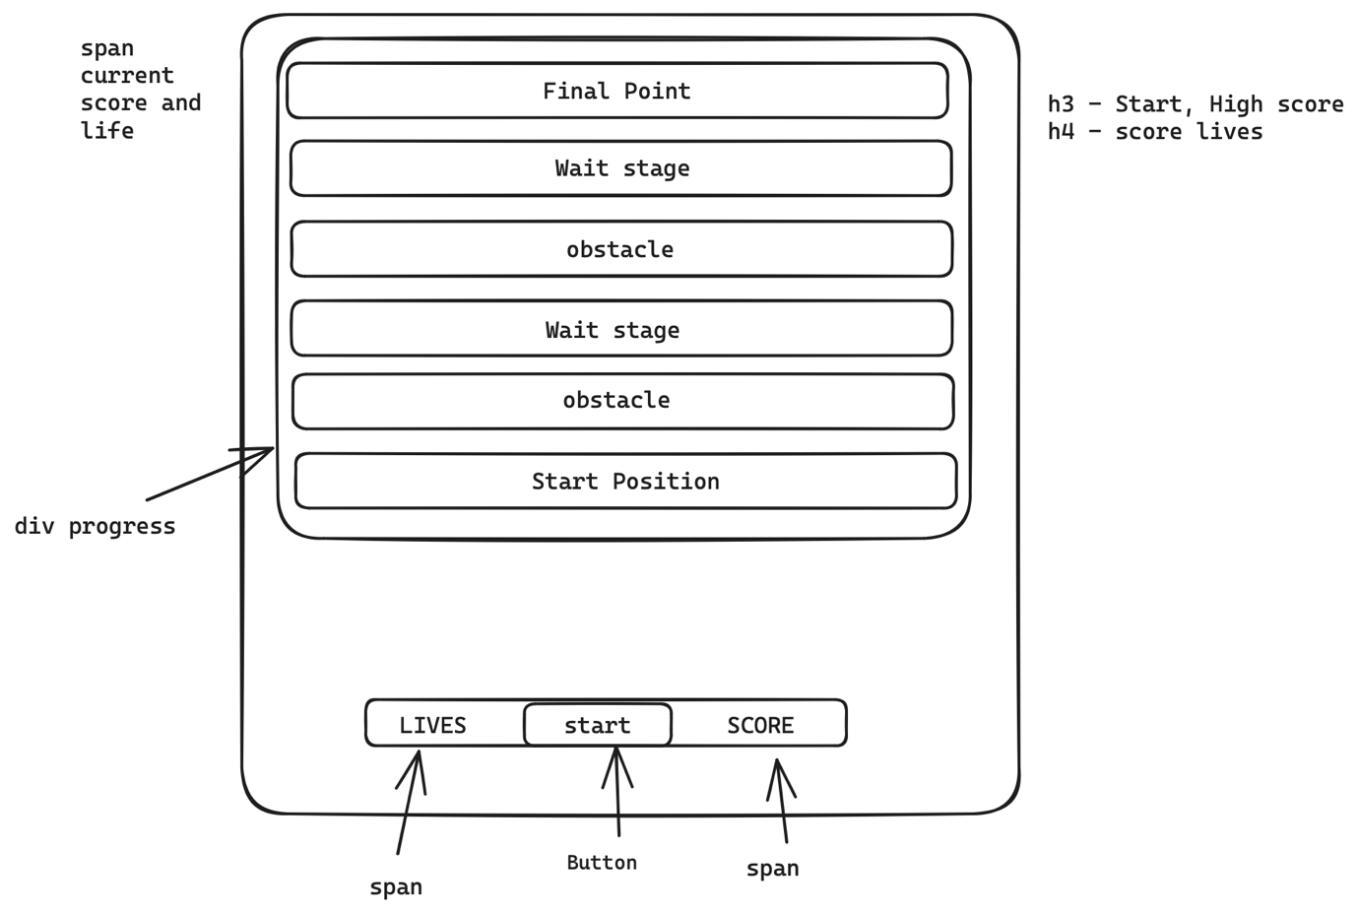
I also did my pseudocode, for have an idea of possible problems that I would have or make my project work. It helped a lot for I look back and return to the point where that I have done my codes and understand what was missing for everything work as should.

Pseudocode
! Elements
current-score (this will be the span tracking current score made)
progress ( i will try add a level count))
amount-life-remaining (span that tracks the amount left life)
button (start the game)
obstacle for the frogger pass
transition for the elements that need to have as obstacle

! Variables
score amount (number) - every time he passes a level, he get 100 points
lives - will have just 3 lives per game (every time something hit, he lose's a life)

completion (number) - the final score from the user (alert window)

! Grid
* Making a grid in JS

This function will create all the grid cells and append them to the existing grid

Set width and height of the div cells, grid will 6 rows for the levels

will be a grid without cell number visible, for track if he still can go up, left, down

obstacle in 3 different lines are my plan, for be more interesting

i will also add 2 lines that he can wait for the best moment to cross.

Build/Code Process

Instructions

The Build/Code Process will be the longest section of your ReadMe and will be most insightful to the engineers that review them. This is where you will discuss the steps you took to code the project.

You want to see your ReadMes as a way to walk the engineers through your approach and problem solving from the start of the project through to the end.

You'll need to include a minimum of 3-4 code snippets, highlighting code you're particularly proud of and these code snippets will have descriptions on what you did, how and why to set the context of the snippet you include. These explanations are important for the engineers, as they will want to understand what you did and the reasoning behind the steps you took.

You don't need to document every single thing you coded, but walk them through the key sections of the project build.

For any group project, you will just focus on your contributions.

Some people will document the build/code process by discussing the key stages they worked on. Others will do a day by day guide. It’s entirely up to you how you structure this, as long as you discuss all the key things above.

Insert your Build/Code Process here:

Day 1 – I started my day one thinking on how to do my project and doing my wireframe.
I search and download the sound and images that I want for my background and looked for possible problems that I could face while build my project.
Day 2 – I started from my grid using flex-box and I added the frog and roads for have a idea from how my layout will look like. At the end of the day I also added the keyUp function to move the frog around the grid.
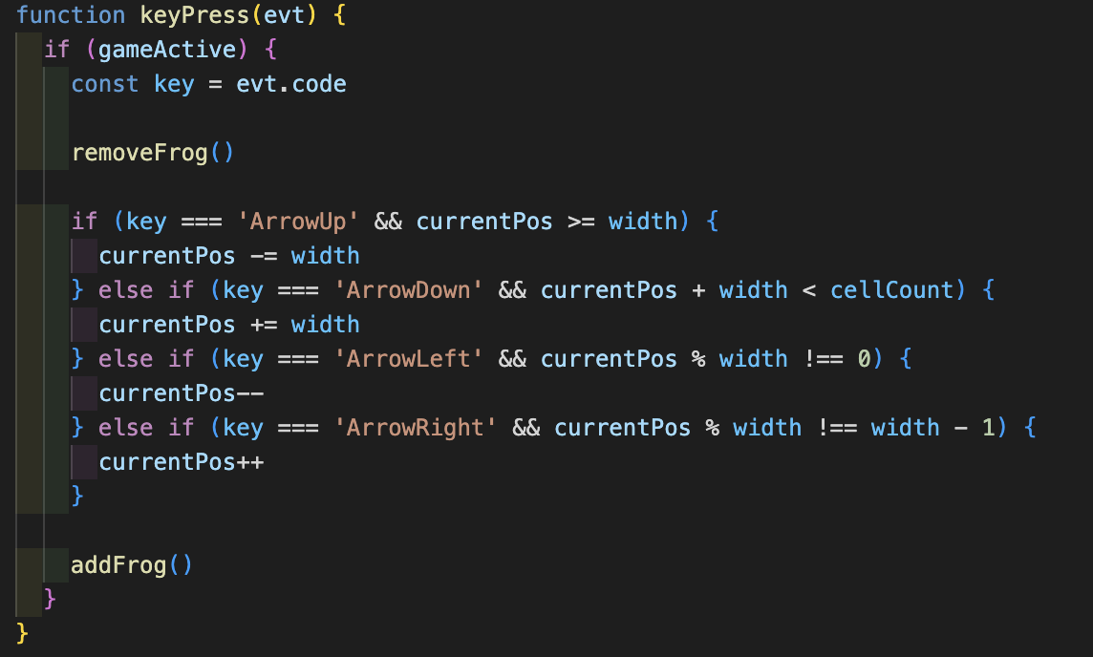
Day 3 – I added the obstacles and I start to think about the move using the setInterval for the speedy, at the beginning I added just a normal movement, but then, we few help, I included the random movement at my obstacles, what at the end looked much better to the game.
Day 4 – I added the music at the background, I resolved few bugs that my game had and I added the level to my game. The user has just one live and 5 level to be able to win the game.
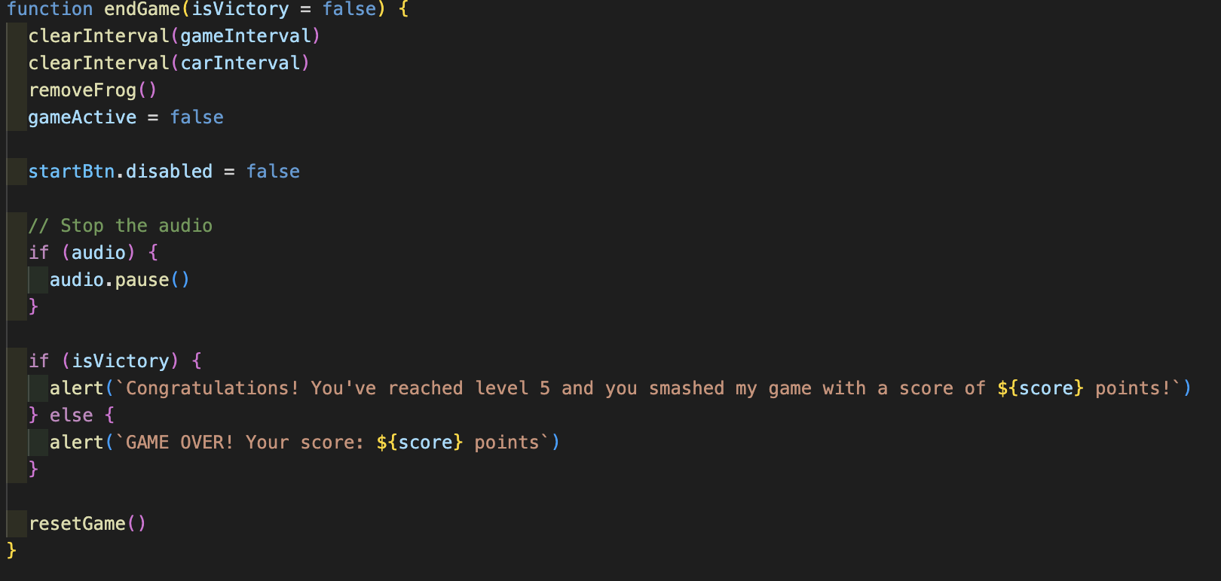
Day 5 – I finished my game for be able to present and I correct the collision detection that has a problem to detect when the cars come from the sides to hit my frog.
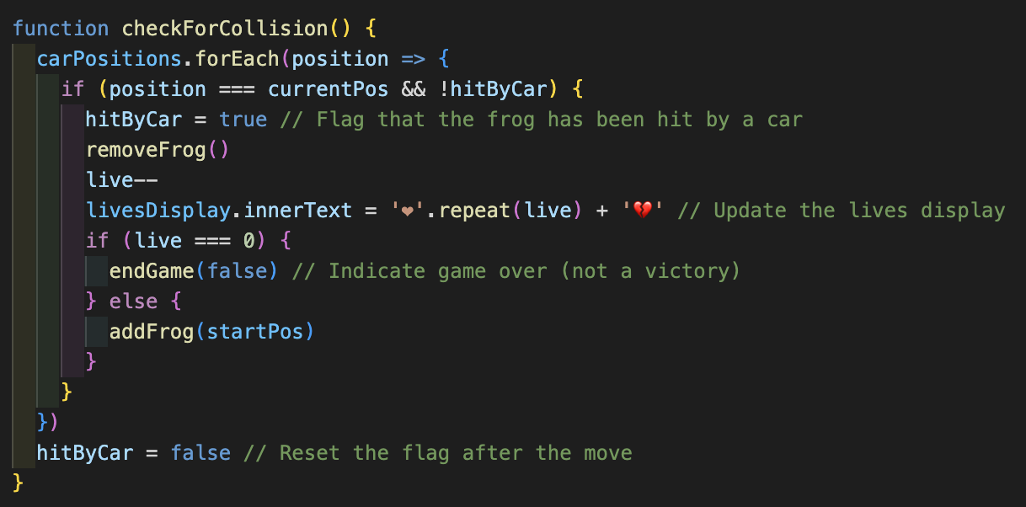
Challenges

Instructions

Challenges are great for showing your learning journey and problem solving, and this is a section that many engineers will check out. Every day of your engineering career you’ll encounter challenges, this is part of your growth and development. It’s the challenges you encounter that helps you become a stronger and more competent engineer.

Here you will detail any particular challenges you encountered as you were coding the project.

Questions to answer here:

- What technical challenges did you come across?
- Why were these challenges?
- What problem solving did you do to rectify them?
- Team dynamics/ Project management
- Tools/Tech you used

Insert your Challenges here:

- What technical challenges did you come across?
I had many challenges in during my project. Till the last minute before delivery the project to my lectures, I had to deal with some issues at my code, but, I didn’t stop to think that I will found a solution for my problems, and I did.

- Why were these challenges?
I couldn’t see where I was doing wrong, so I decide to print few parts of my code and then I saw that I was calling the same function different times and with different names.

- What problem solving did you do to rectify them?
I printed to be better visual as my code wasn’t long so I could do it. I search for functions that I could use at my code, and happily founded it.

- Team dynamics/ Project management
I love to work with project management, and as I did this project while I’m working full time, I used the project management to be able to program myself better.

- Tools/Tech you used
VS, Javascript.
Wins

Instructions

The Wins section is your opportunity to highlight the aspects of your project you are most proud of. See this as your chance to showcase these parts of your projects to the engineers reading your ReadMes.

Things you could discuss here:

- Interesting problem solving you did
- Strong sections of code
- Collaboration with other team members
- Visual design of the project

Insert your Wins here:

My win for this project was to resolve all the problems that I had in one night and don’t stop to think that this would be possible for not even a second.
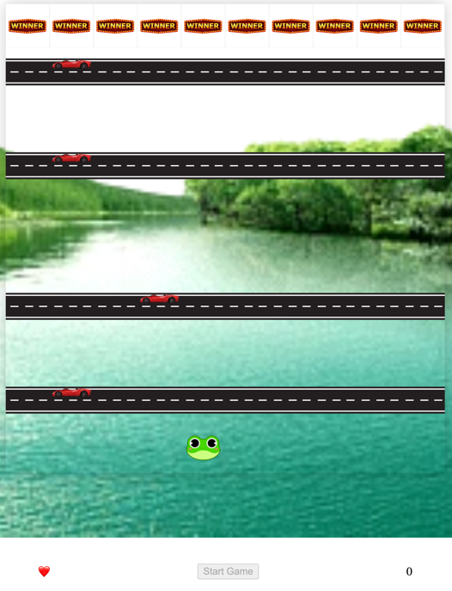

I also liked of the part of my code from where the car should pass, start and finish and also be able to have a random movement, instead of a linear.

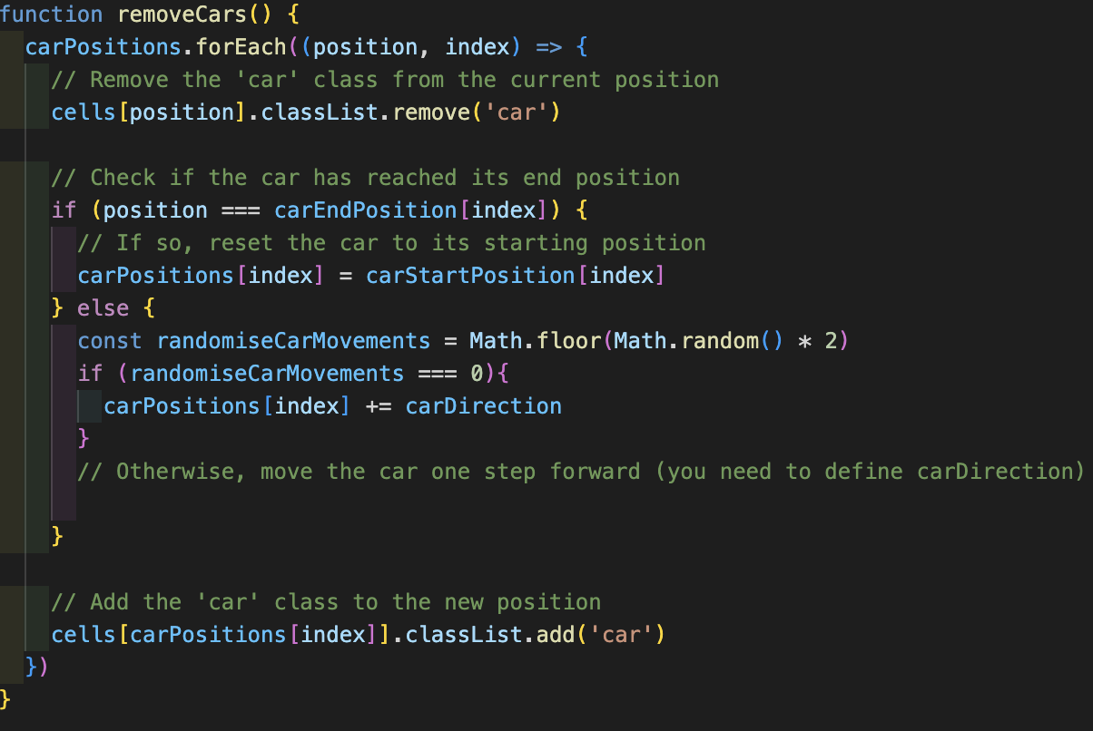

Key Learnings/Takeaways

Instructions

This section is one of the other most important parts of your ReadMe from an engineers’ perspective and helps to differentiate each of you from your classmates and team members.

Engineers love to understand what you learn from each project and how it has shaped you as an engineer.

See this as your opportunity to show the engineers how your skills grew during each project sprint.

Things you could discuss here:

- What Technologies/Tools do you now feel more confident with? Tell them specifically what you learnt about these.
- What engineering processes did you become more comfortable with? Standups? Pair programming? Project management? Tell them what you learnt from these processes?

Insert your Key Learnings/Takeaways here:

- Learned how to create a loop for music continue playing.
- Learned how to use play() functions to control the audio.
- Learned how to use Flex-box.
- Learned how to use random for move the obstacles.

Bugs

Instructions

If you have any bugs in your project, it’s important that you flag them in your ReadMe. This helps the engineers reviewing your projects to understand that you are aware that there are issues - if you don’t flag these, then they won’t have that visibility that you know these problems are in your code and it can result in them not having a full understanding of your technical knowledge.

In either sentences or bullets, explain what the bugs are.

If you have no bugs, you can leave this section blank.

Insert your Bugs here:

There aren’t any bugs that I could see, I would like to keep working on it for make a better look to my game.
Future Improvements

Instructions

It’s common to get to the end of your project and have ideas on what you would do if you have more time, as well as how you might improve it.

If you do, you should detail this here. It’s great to give that context on potential future improvements, to share your creative or technical ideas with the engineers reading your ReadMes.

In either sentences or bullets, explain what your future improvements would be.

Insert your Future Improvements here:
I would like to continue work on my project to make it look better and for add more functionalities to my game as pop-up, crash sound and victory sound.

